|  |  |
| --- | --- |
| Course Name | ITD-2313 Script Programming |
| Instructor | M. Schnell |
| Student Name | Bridgette Johnson |
| Due date | 3/5/2023 |
| Grade | <grade earned here> |
| Grading Comments | <instructor comments here> |

## Scripting Projects Assignment - Week 7

Project 1

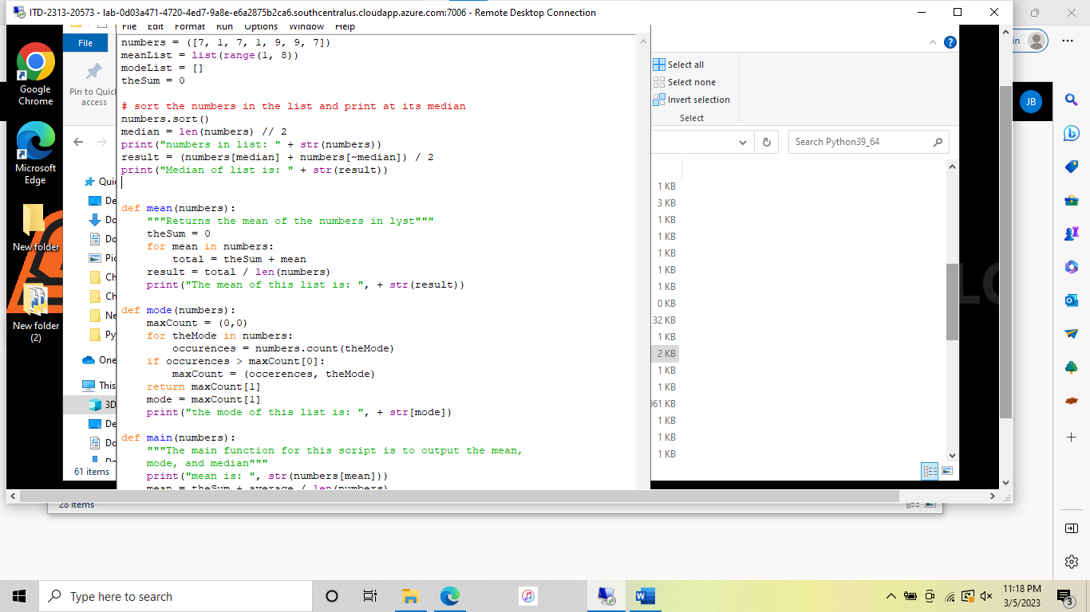

Project 2

